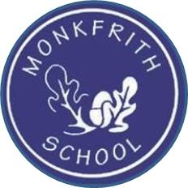
19th March 2020

Dear Parents,
COVID-19 Home Learning for the EYFS

This is a challenging time. As a school, we have a responsibility to provide work for your children if the building is closed. The Government have now announced that schools will close from Friday (except for some key groups) and therefore I am sharing information about how we will be supporting children learning at home. Arrangements for key worker will be shared when we have more information from the DfE.

Children who are in school today will be sent home with some work, books etc. School is still open tomorrow and the children will be having a lovely time! If your child is currently not in school, but you would like to collect any materials, then you can come to school tomorrow between 9.30 and 11.30 or between 1.30 and 2.30pm. If you are currently self isolating and are not able to pick it up, but you would like to make an alternative arrangement for someone to collect on your behalf, then please do so. At the moment, it appears that School will be open next week and it could be collected then.

I am sure you understand that this is the first time we have had to make such arrangements and there will inevitably be some issues along the way so we ask that you are flexible and bear with us if there are technical problems.

Setting an appropriate level of work for each child in circumstances such as these, is challenging as we recognise each child is an individual and every family will have to make their own arrangements due to access of resources, supervision and their own personal circumstances.

It would be advisable that you put in place a routine to give the children structure at, what is otherwise, a difficult time.

If you have any queries then you can email the Office and we will get back to you as soon as we can.
Kind regards,

Jude Deasey

Here is an overview to help you support your child’s learning at home.
As you are aware, the approach to learning in the EYFS focuses on learning through play and providing opportunities to enrich language as part of play. Therefore, our aim is to support you in continuing to keep your child’s learning as practical and play-based as possible.

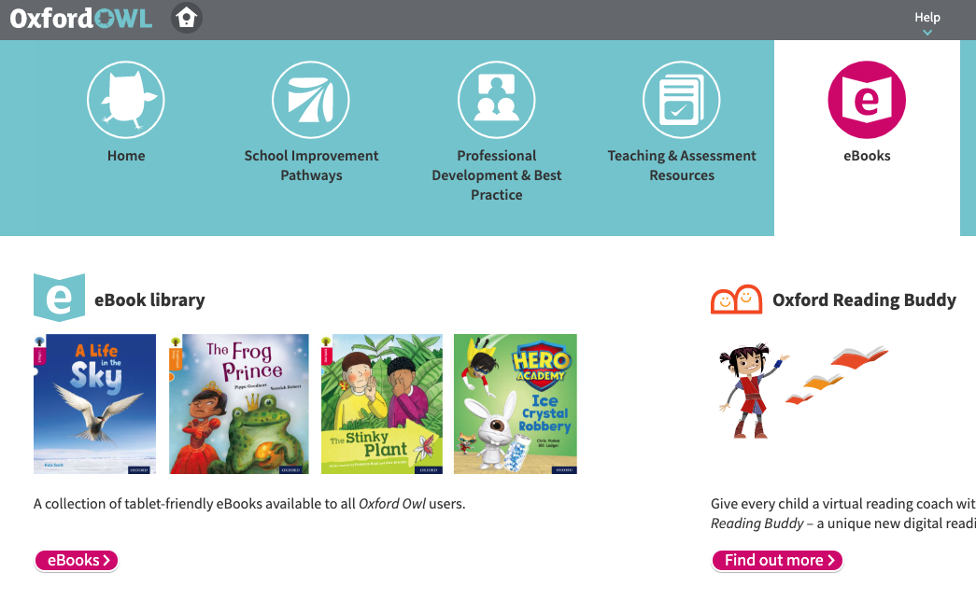
Reading
Please continue to read with your child everyday for at least 10 minutes.
Your child has been given 2 new phonic readers,
2 new guided readers and 1 class library book.
In addition, Oxford Owl offers a great range of phonic ebooks for children to access for free online; all you need to do is sign up. https://www.oxfordowl.co.uk/?selLanguage=en&mode=hub
Children enjoy reading and listening to the stories and each book has a set of questions and activity ideas.
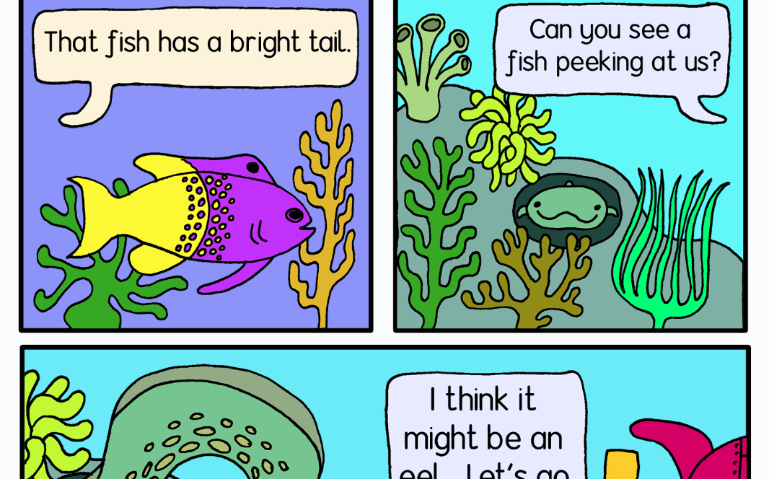
There is also a great range of phase 3 and phase 4 decodable comics available for children to access at: http://www.phonicsplaycomics.co.uk/comics.html .
Please continue to practise the new sets of tricky words with your child.
These will be available to access on the home learning page on the school website.

Storytime
Superstar writers Oliver Jeffers https://www.instagram.com/oliverjeffers/ and Mac Barnett https://www.instagram.com/macbarnett will each be reading one of their books on Instagram every day, and talking about how they wrote them. Also enjoy live storytelling by children’s authors at: https://www.carylhart.com/special-projects/author-events?fbclid=IwAR1jbvmbr6WBtfaY3hym37m2dRgvdUiumBJFmXOLJ9hYiUc7lUYtsrh5QgQ

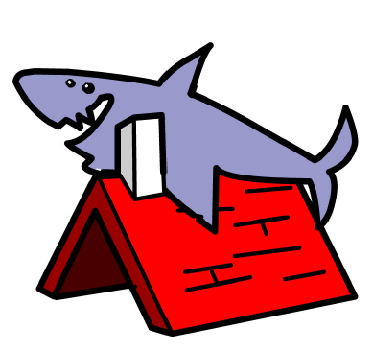
Writing
Your child’s letter formation book is now back in their book bag. Inside you will find the last set of trigraphs to practise, some tricky word pages to practise word writing and the ‘letter families’ handwriting sheet to refer to. There is also a booklet containing some phase 3 and 4 pictures for children to think of sentences to link to each picture (more will be available on the school website). Children are very familiar with doing this in school. Please work with your child for at least 10 minutes a day.
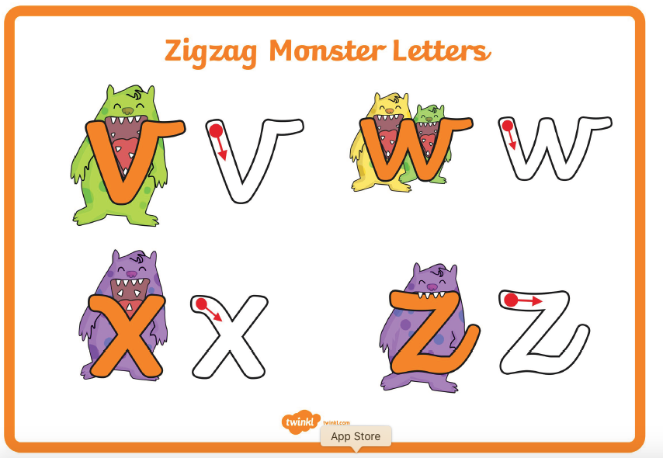
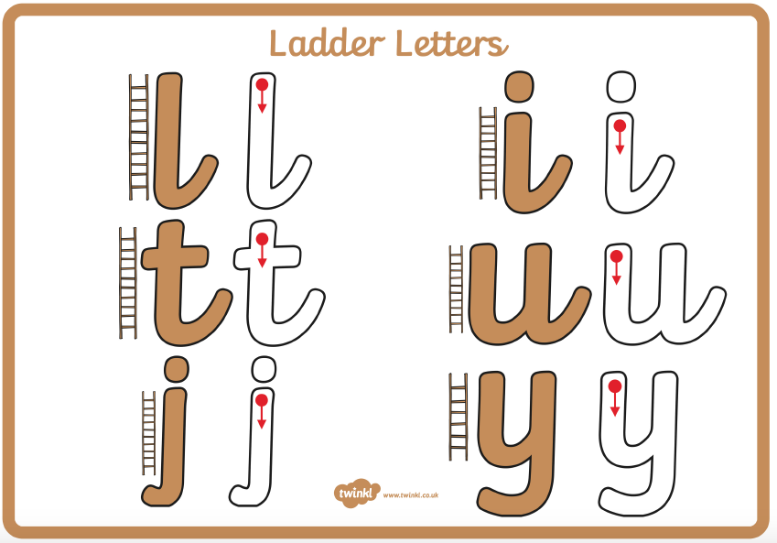
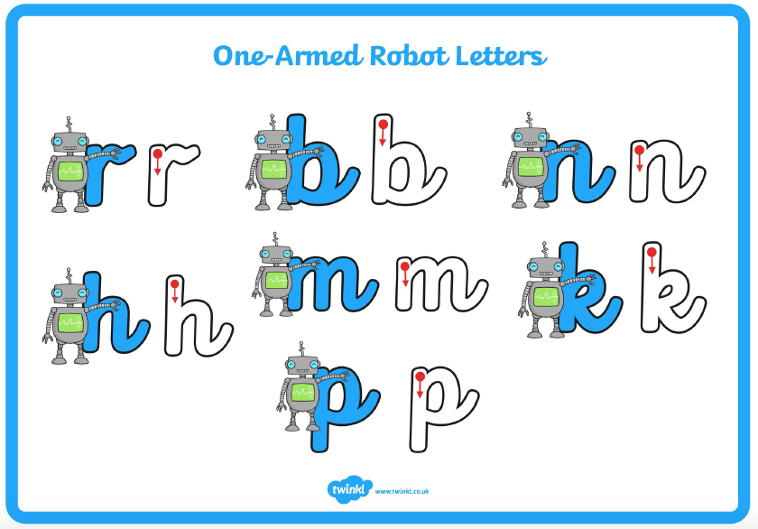

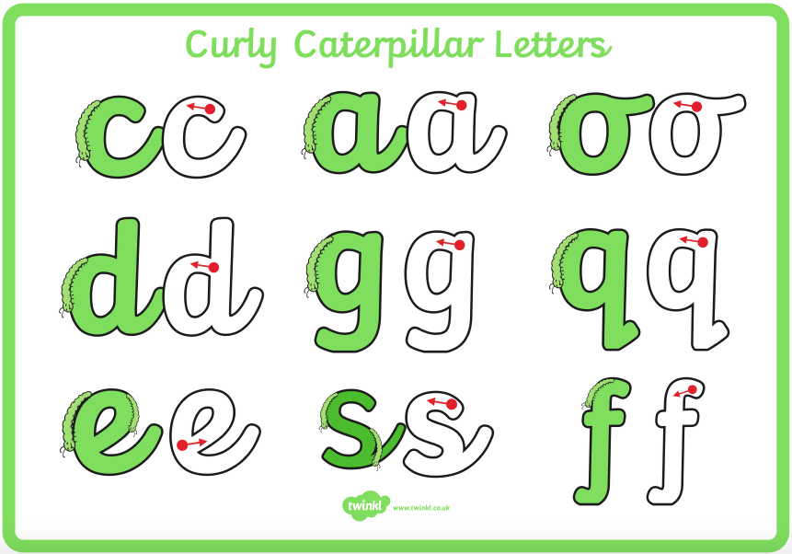

Maths and Fine Motor
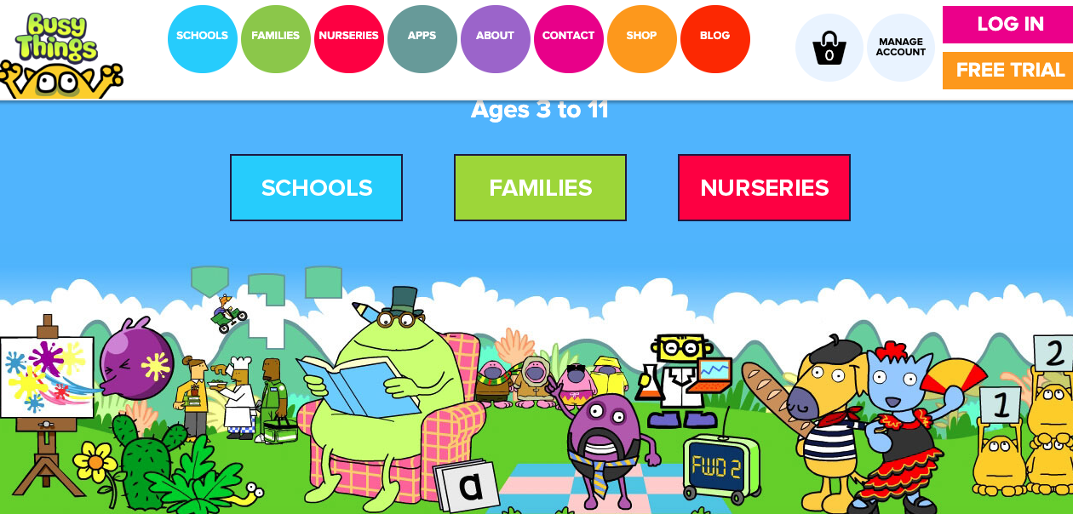
We will be posting practical maths and fine motor challenges regularly on tapestry. These will be things that you can do with your child using everyday resources at home. You will then be able to upload photos and videos in response to these challenges and we will be able to communicate with you on your posts.

There are also a number of websites to support your child’s learning at home. Busy Things https://www.busythings.co.uk/ has a wide range of games for children to play independently to support their Maths and Phonic Knowledge. They are currently offering a free trial.
Phonics Play https://new.phonicsplay.co.uk/ is another great website and it is also offering a free month membership using the username: march20 and password: home.

Understanding the World
Last week we began learning about plants and changes over time. We have asked the children to continue to look after our beans and help them grow at home. They will be sent home in brown envelopes, ready to put into a plastic bag on a window or straight into a pot. We have also provided a weekly diary for children to draw, label and write about the changes over time. If you are unable to collect a bean from school and would like to give this a go with your child, any packet bean will work. We have used butter beans.
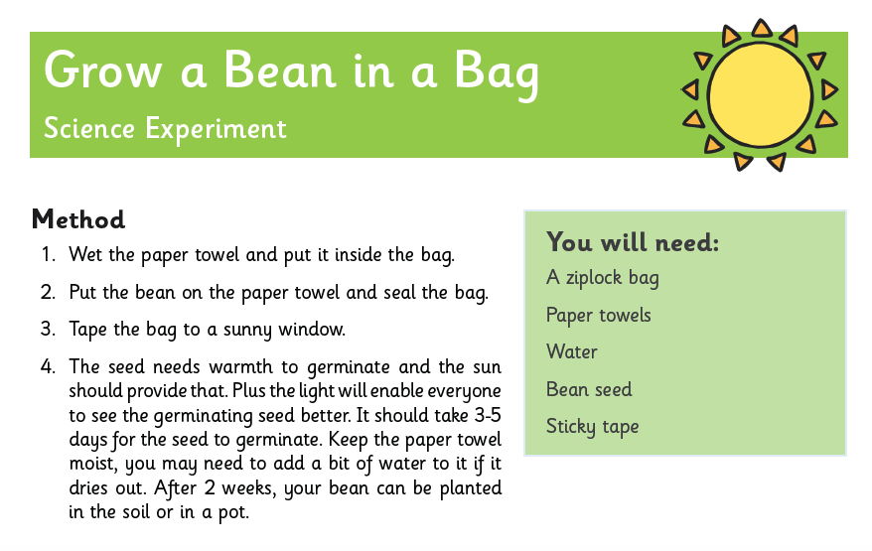
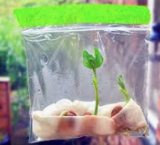

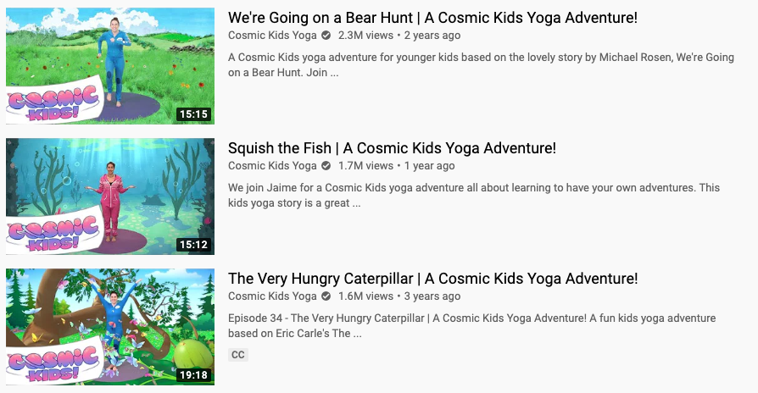
Yoga
Cosmic Kids Yoga https://www.youtube.com/user/CosmicKidsYoga is a great way to help children practise their attention and listening skills and gross motor movement in a calm and engaging way. There are lots of engaging videos available on youtube using storytelling to support exercise.

All the resources mentioned in this letter will be available to download on the ‘Home Learning’ section of the school website. Tapestry will be the main tool of communication for Reception. Here we will set new challenges for Phonics, Maths, Fine Motor and Understanding the World and respond to children’s learning as regularly as possible. If you have any issues accessing Tapestry, please contact the office.

Thank you for your continued support,

The Reception Team

